US HOME PRICE INDEX PREDICTION

The data set contains the following parameters of 20 years that will affect HOME PRICE INDEX or HPI in future,

* Sale Price: Increase in sale price over the years can make changes in HPI.
* City : Some cities have high land values than others due to various reasons that affects HPI.
* Land value: Increase in land value over the years can make changes in HPL.
* Square feet(sqft): More demand in sqft means more land value that affects HPI.
* Stories: If a home have more stories then the price of home will be more compared to other homes.
* Beds: More beds mean more property value.
* Bath full: Full bath can add up to extra 20 charge on home price compared to half bath or quatre
* Bath 3 quatre
* Bath half
* Garb square feet
* Gara Square feet
* WFNT
* Golf
* Green Belt
* Noise traffic
* View rainer
* View Olympic
* View Cascades
* View territorial
* Submarket: If a home situated near a branded submarket, then the home price will be more compared to others.

All the variable from WFNT to View territorial are the extra benefits asked by the buyer, adding this can increase the cost of home to some extent that would affect HPI.

**EXPLORATARY DATA ANALYSIS**

**Teck Stack Used: Power BI for visualization and graphs.**

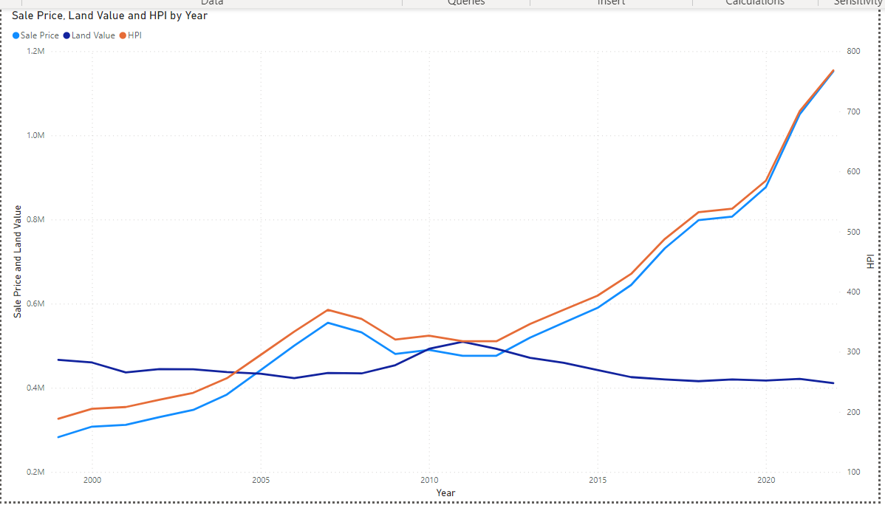

From this above graph we can observe that both sale price and HPI is positively correlated.

As the sale price increase HPI also increases. Although land value falls after 2010 yet HPI and land value increases. Hence, decreasing in land value does not affects sale price and HPI negatively.

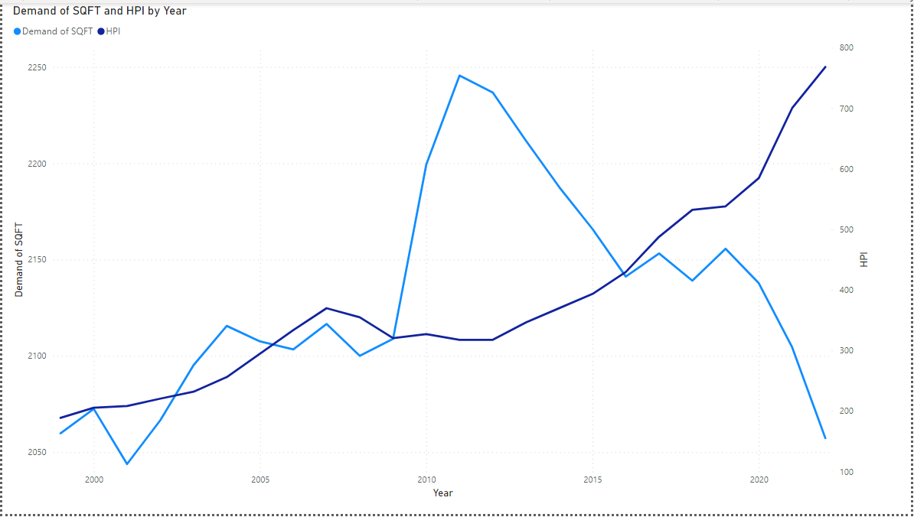

From the above graph we can observe that demand of sqft decreased a lot after 2010 and it fell drastically after 2020. This implies people are not demanding larger land rather they are interested in a good design in a smaller area. Due to this reason, HPI is increased over the years because sale price is decided by the design of the house rather than area size. Due to increase in population sellers cannot give much area to a buyer, but they are increasing the price of the house by making the house more attractive through extremely beautiful interior and exterior designing.

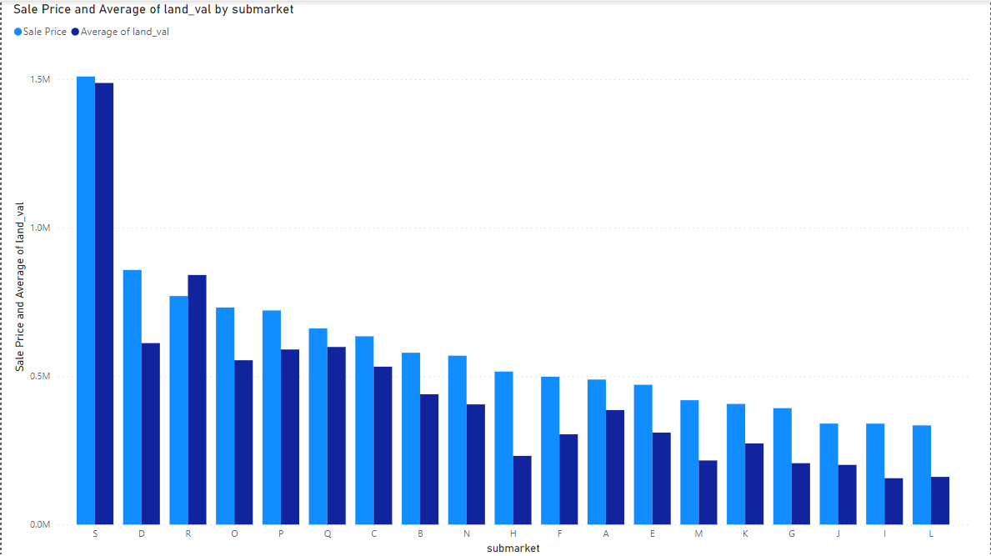

From the above graph we can say that submarket S is most expensive compared to other submarket and submarket L is the least expensive.

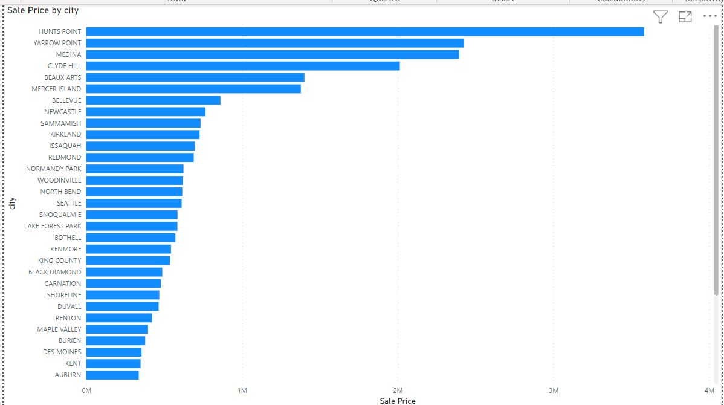

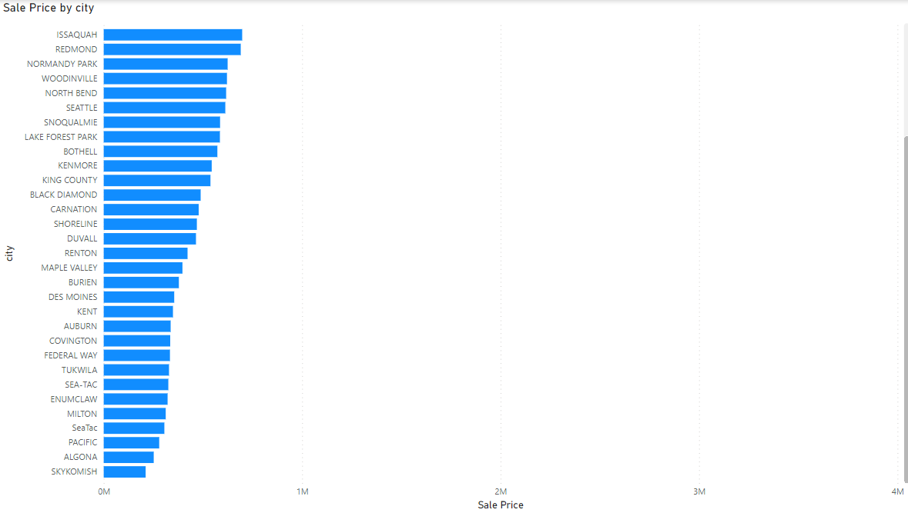

From the above graph we can say that Hunts Point is most expensive city and Skykomish is least expensive city.

**MODEL CREATION**

**Teck Stack Used: Python**

**Algorithm Used: Linear Regression, Ridge Linear Regression and Lasso Linear Regression.**

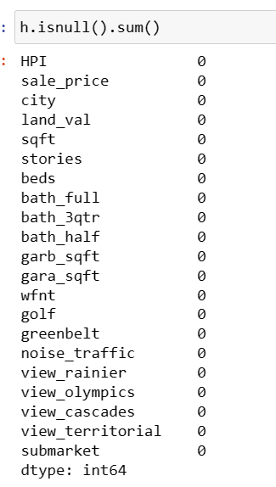

No null value in the data.

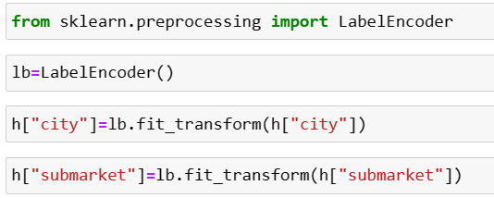

Used label encoder to give dummy variables to categorical variables.

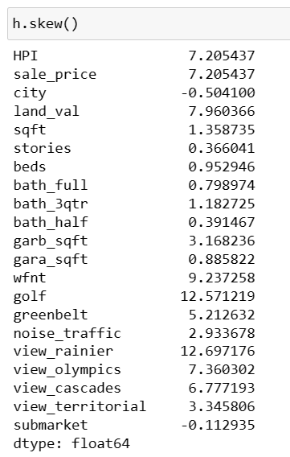

The acceptable value of skewness is considered to be between -3 and +3.

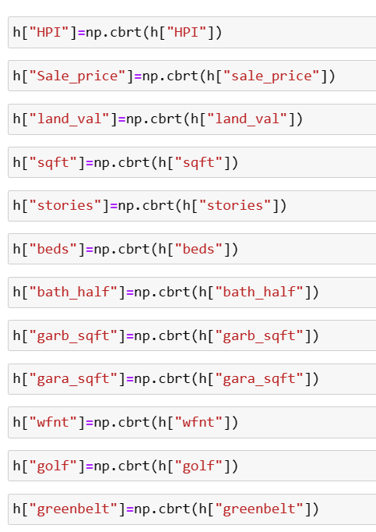

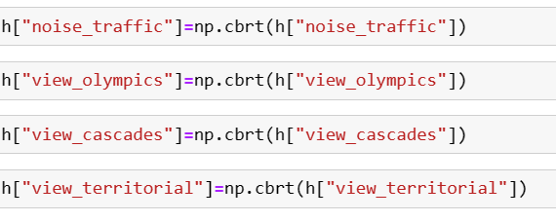

Skewness removed using CBRT method.

I have used cube root method; it is efficient in removing high skewness that is present in dataset and it can be also applied to zero and negative values. As here I am using Linear Regression hence, I should meet one of the most important assumptions of Linear Regression that is the data should be in normal distribution. I applied CBRT to all the variables to make the skewness closed to zero. So that the model works fine.

Skewness = 3(Mean-Median)/Standard Deviation

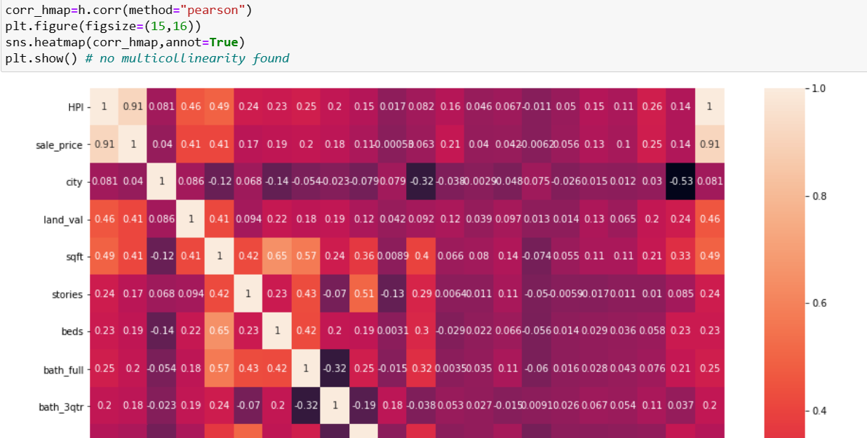

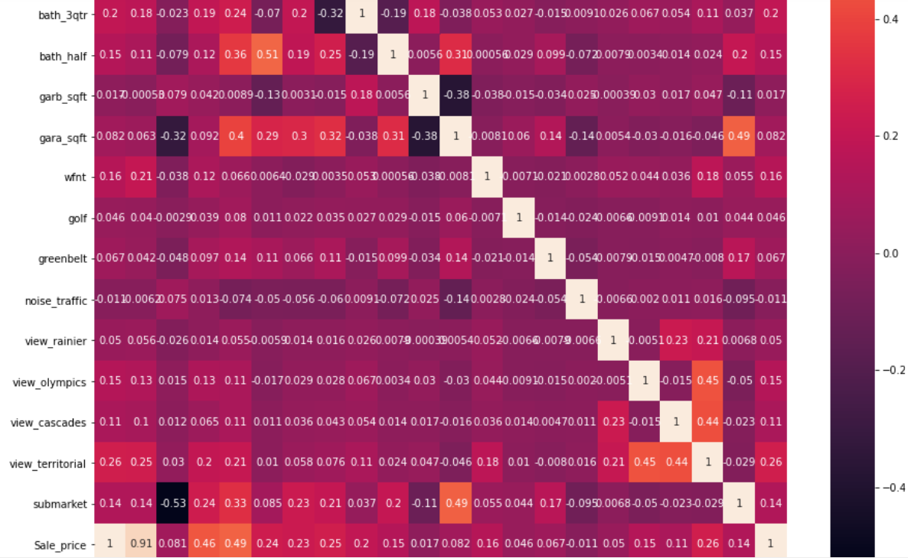

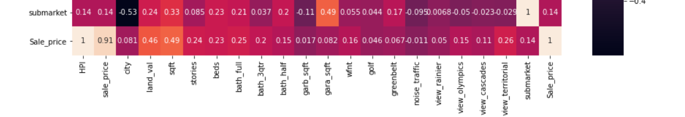

No multicollinearity presents in the data, this satisfies another most important assumption of Linear Regression. In case of high multicollinearity, the model will get overfit.

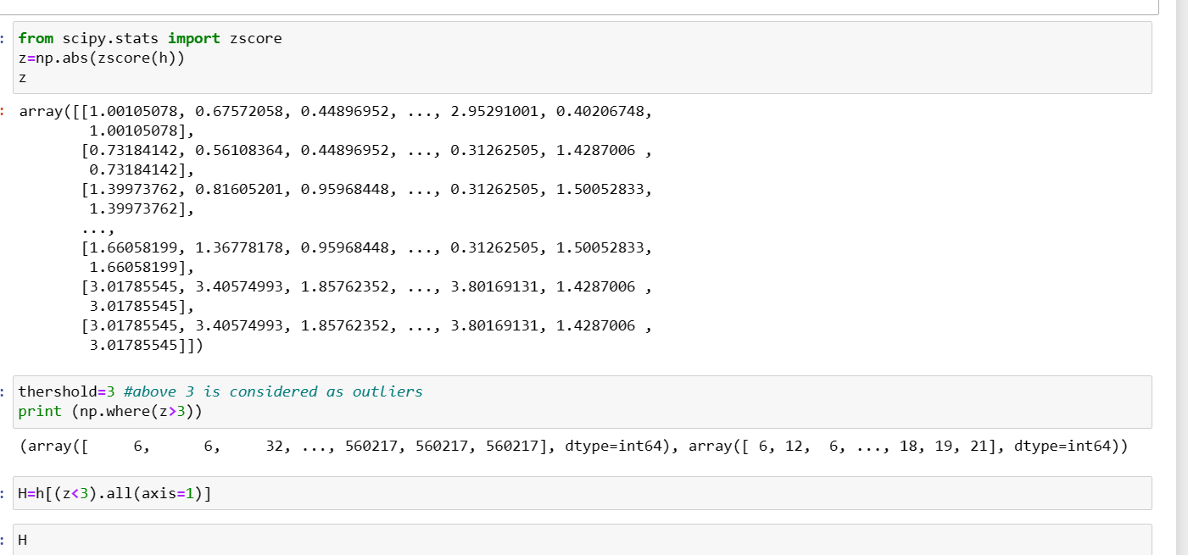

Using Z score method to remove outliers to satisfy another most important assumption of Linear Regression.

Z score formula= X- Mean/ Standard Deviation

X is the observed value.

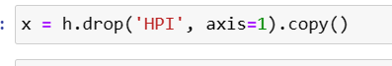

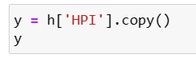

Y variable is Home Price Index or HPI

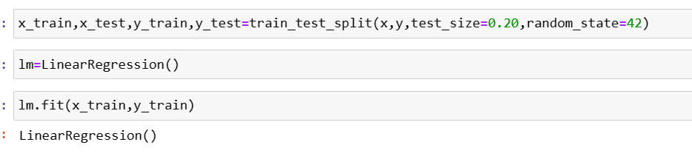

Using Linear Regression to predict

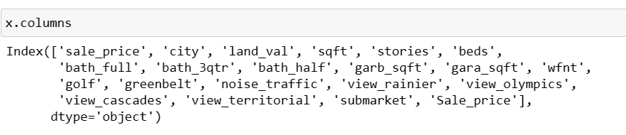

These are all X variables.

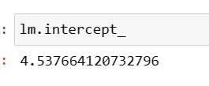

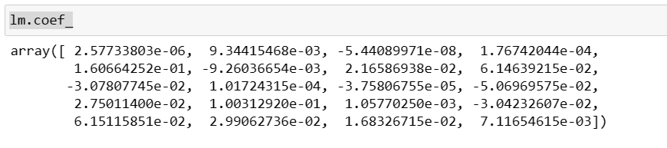

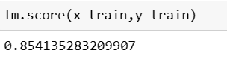

We can see that this model is very efficient in prediction future HPI as accuracy score is 100%.

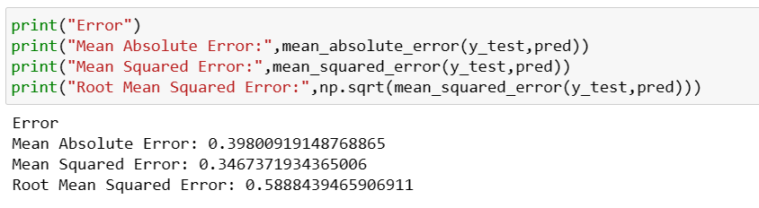

Error is less.

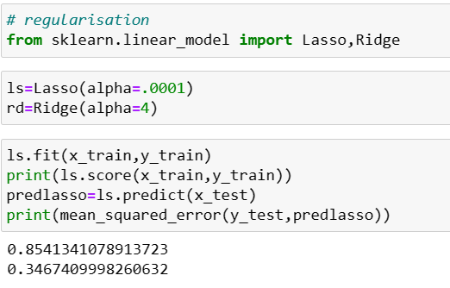

Implementing Lasso regression is giving accuracy score 85%.

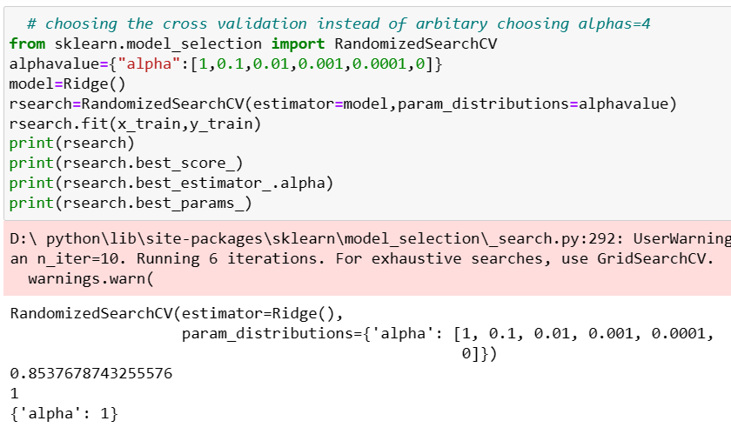

Ridge regression is also giving 85% accuracy.

I could have used standard scaler to remove outliers but the formula of Z score and standard scaler is same. And after applying Z score the model is working fine.

Both Lasso and Ridge is regularization technique but I prefer Ridge because it helps to reduce overfitting problem by decreasing the larger coefficient whereas lasso make coefficient some variables zero that means some variables gets eliminated from the model. And Ridge regression is best when the number of variables is large.

In this case although Linear Regression is giving 85 % accuracy score yet I will choose Ridge regression as the best model because it has giving me the best model after cross validation every parameters.

This is the model I have created to predict HPI, and I would recommend Ridge Linear Regression where Apha=1 as the best model to predict HPI in future .